6/8/2026
Niraj Wandre
Unique System Skills (India) Pvt. Ltd.
Wazuh SIEM Security Lab
Building a Real-World Security Monitoring System using SIEM

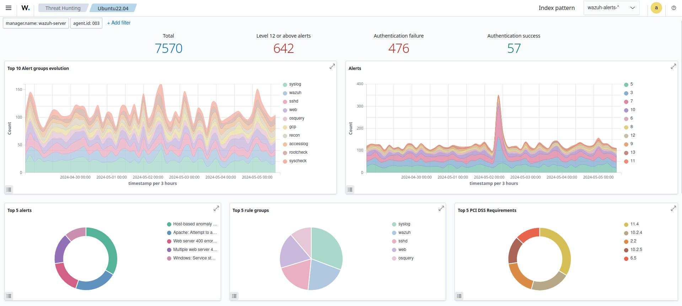
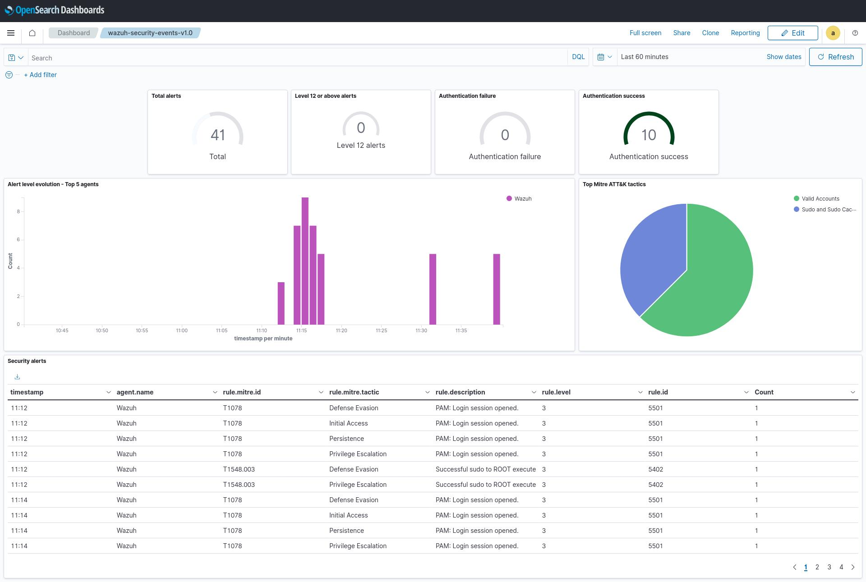

Introduction
What is SIEM?
SIEM = Security Information and Event Management
Kaam:
- Logs collect
- Logs analyzed
- Threat detect
- Alerts generate
- SIEM security devices aur systems se logs collect suspicious activities detect.



Objectives
- Wazuh Manager setup
- Windows Agent connect
- File Integrity Monitoring configure
- Security Events monitor
- Alerts analyzed

Windows Agent
|
|
V
Wazuh Manager
|
|
V
Wazuh Dashboard
|
|
V
Security Alerts

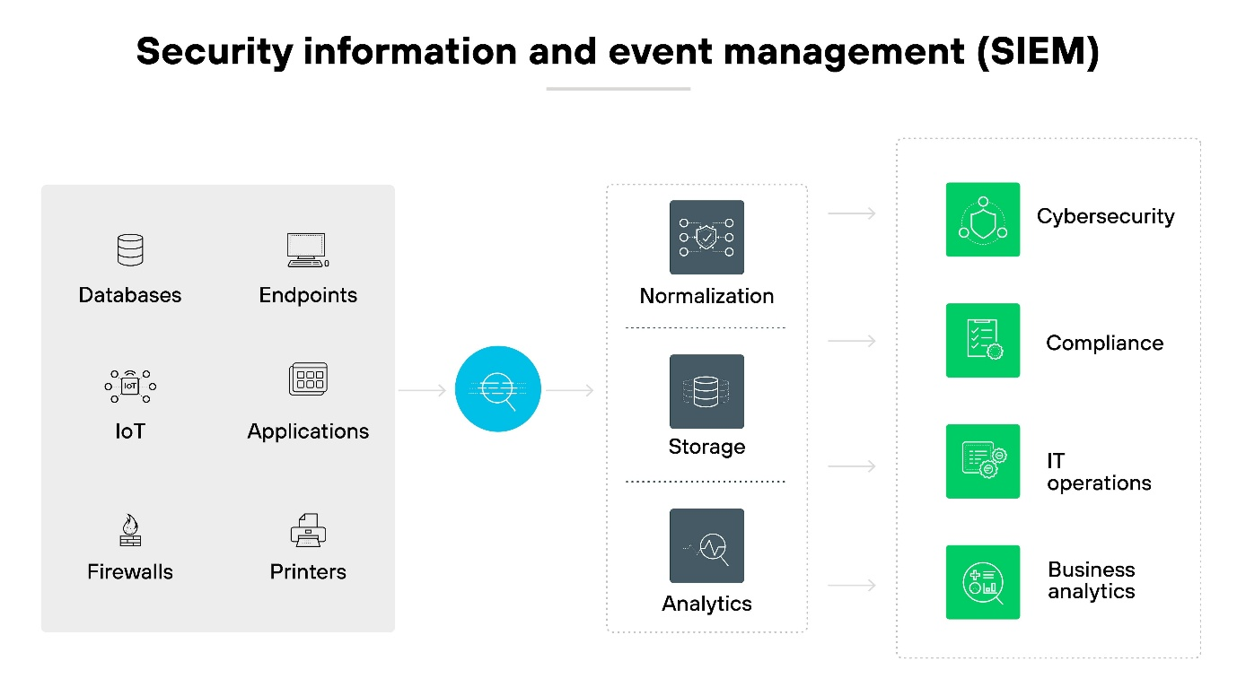

Components Used
Hardware
- Laptop
- 8GB RAM
Software
- VirtualBox
- Wazuh v4.14.5 OVA
- Windows 10
- wazuh-agent-4.14.5-1

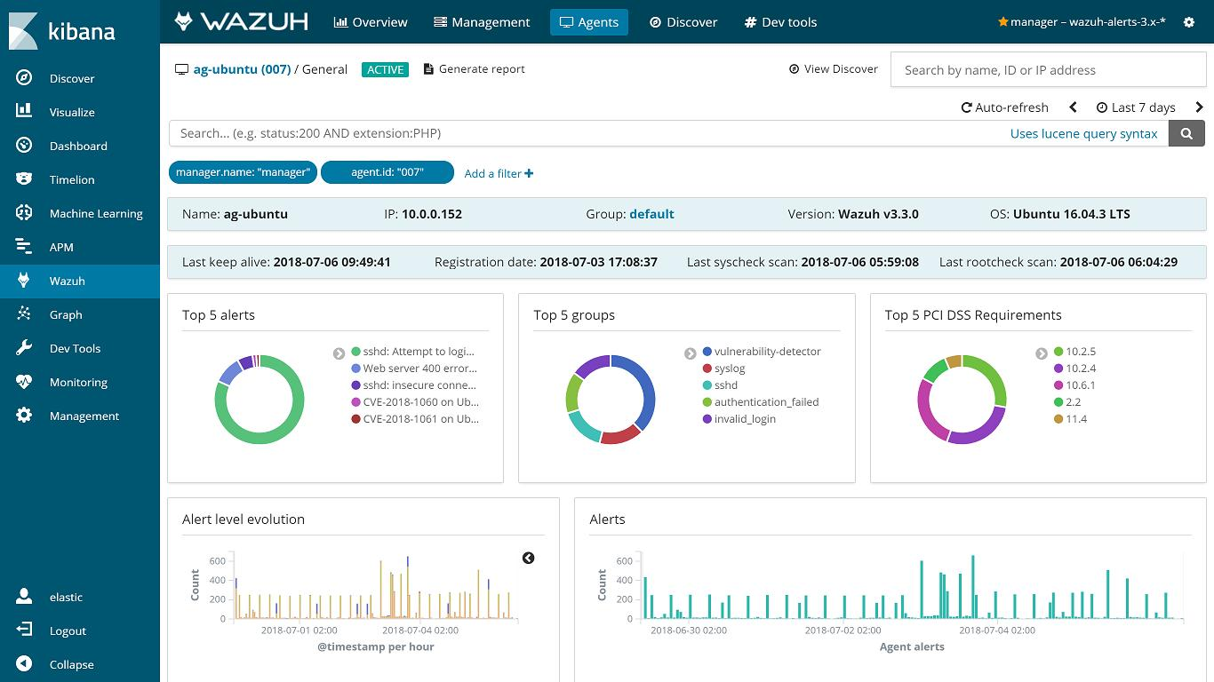

Implementation Steps
Step 1
Open vm and start the Wazuh in vm box and use the login id wazuh-user and pass Wazuh
Than you check the IP of Wazuh 192.168.1.6
Step 2
Open chrome and type https://192.168.1.6 and enter
Then check the connectivity.
Step 3
Connect agent with manager you just check agent and manager connect each other
Step 4
Click windows button type cmd and open as admin open it
Than check the agent is working or not
Start the agent : (net start Wazuh )
End the agent : ( net stop Wazuh)
Step 5
Open c drive and type : C:\Program Files (x86)\ossec-agent
Than open ossec.conf and do change this program little bit change
Set the frequency 5 and in syscheck ad last one line.
Step 6
Than modifile Niraj file and check in event you see every thing.

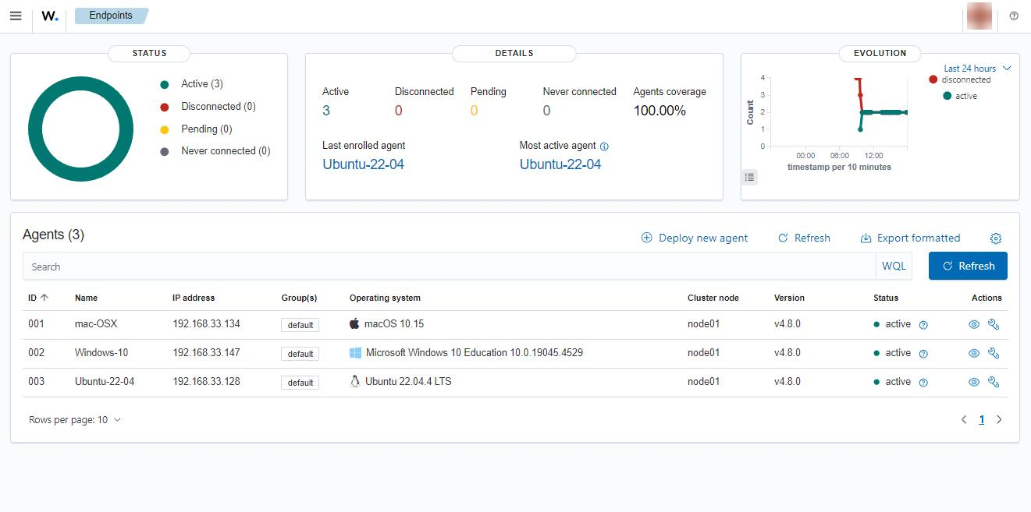
File Integrity Monitoring (MOST IMPORTANT)
What is FIM?
File Integrity Monitoring :
- File Create detect
- File Modify detect
- File Delete detect

- Dashboard Analysis
- Dashboard sections:
- Overview
- All security events
- Security Events
- Alerts
- Integrity Monitoring
- File changes
- Agents
- Connected machines

- Results
- Achievements
- ✅ Agent Connected
- ✅ Logs Collected
- ✅ File Monitoring Enabled
- ✅ Alerts Generated
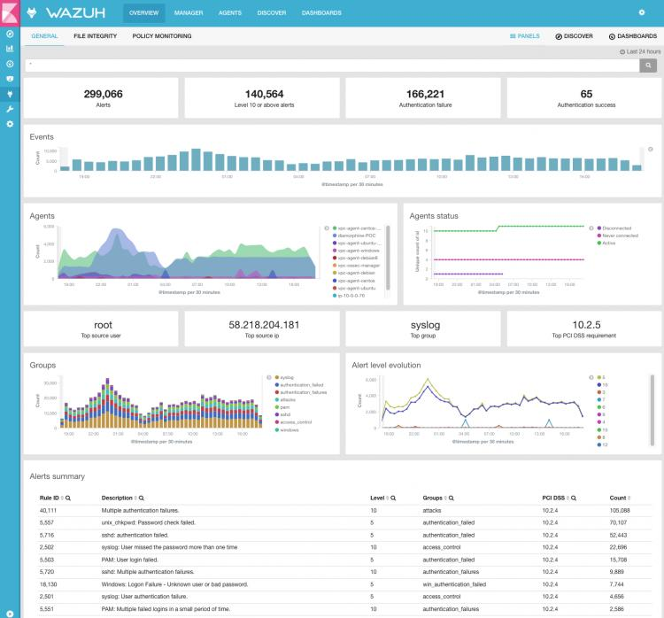

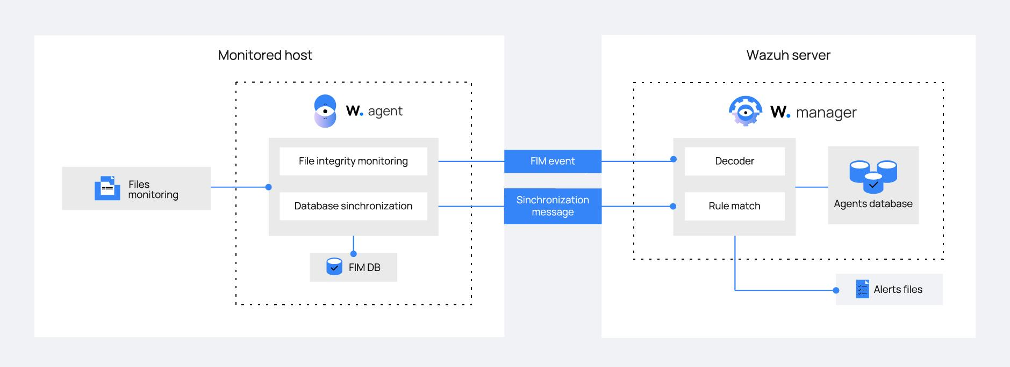
Conclusion
- Successfully implemented Wazuh SIEM
- Connected Windows Agent
- Configured File Integrity Monitoring
- Generated Security Alerts
- Learned SOC Monitoring Concepts
My project is Wazuh SIEM Security Lab. Wazuh is an open-source Security Information and Event Management platform. I deployed a Wazuh Manager on Ubuntu and connected a Windows Agent. Then I configured File Integrity Monitoring to monitor files and directories. Whenever a file is created, modified, or deleted, Wazuh generates an alert which is displayed on the dashboard
